1. Objective
The objective of this task is to analyze a real-world sales dataset to derive meaningful business insights. The task focuses on cleaning raw sales data, computing key sales performance indicators, visualizing trends across time, product categories, and regions, and translating analytical findings into actionable business recommendations suitable for decision-making by stakeholders.
2. Dataset Description
The dataset used for this analysis is the Sample Sales Data sourced from Kaggle. It contains transactional sales records of a company operating across multiple product categories and geographic regions.
Key characteristics of the dataset:
- Time period: 2003–2005
- Data type: Transaction-level sales data
- Key variables:
- Order details (Order Number, Order Date, Quantity, Sales)
- Product information (Product Line, Product Code)
- Customer and geographic information (State, Country)
- Original file: sales_data_sample.csv
- Cleaned file: cleaned_sales_data.csv

3. Data Cleaning & Preparation
Data cleaning was performed using Python.
The following KPIs were computed to assess overall business performance:
1. Total Sales
Represents the total revenue generated during the period under study.
2. Total Orders
Calculated as the distinct count of order numbers, reflecting the total number of unique customer orders.
3. Average Order Value (AOV)
Computed as:
$$\text{Average Order Value}=\frac{\text{Total Sales}}{\text{Total Orders}}$$
This metric provides insight into customer purchasing behaviour and revenue efficiency per order.

Visual Analysis & Insights:
Monthly Sales Trend
The monthly sales trend visualization highlights fluctuations in revenue over time. Sales exhibit noticeable peaks during specific months, indicating possible seasonality in demand. The decline observed in early 2005 suggests either reduced demand or incomplete data for that period.
Insight:
Sales performance is not uniform across months, suggesting seasonal buying patterns that can be strategically leveraged.
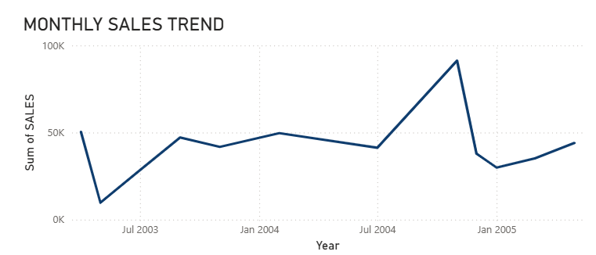
Sales Contribution by Product Line
This visualization compares total sales across different product lines. Classic Cars and Vintage Cars contribute the largest share of revenue, while categories such as Ships and Trains contribute comparatively less.
Insight:
Revenue is highly concentrated in a few product categories, indicating opportunities for focused investment.
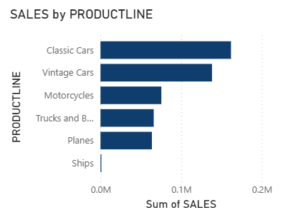

Top Products by Revenue
The product-level analysis shows that a small number of product codes generate a disproportionately high share of total sales.
Insight:
High-performing products play a critical role in overall revenue generation and should be prioritized in inventory and marketing decisions.
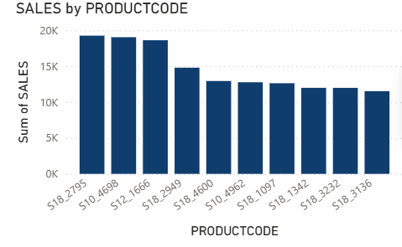
Regional Sales Performance
Regional analysis indicates that certain states outperform others in terms of total sales. This suggests geographic concentration of demand.
Insight:
Sales performance varies significantly by region, highlighting the importance of location-specific strategies.
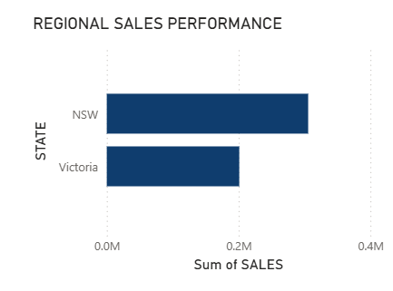
Actionable Business Recommendations:
Based on the analysis, the following five actionable recommendations are proposed:
- Prioritize High-Revenue Product Lines
Allocate more marketing and inventory resources to Classic Cars and Vintage Cars, as they contribute the highest share of total revenue.
- Leverage Seasonal Demand Patterns
Increase promotional campaigns and inventory levels during high-performing months to maximize sales during seasonal peaks.
- Focus on Top-Performing Products
Ensure consistent availability of top-selling product codes and consider bundling or premium pricing strategies for these products.
- Strengthen High-Performing Regions
Expand sales operations and targeted marketing efforts in top-performing states to further capitalize on existing demand.
- Improve Average Order Value
Introduce cross-selling and upselling strategies, such as product bundles or volume discounts, to increase the Average Order Value.

